**A PROJECT REPORT ON HOSPITAL MANAGEMENT DATABASE**

**submitted by,**

**B.Pranesh Kanna[192211608]**

**Manisankar.S [192224196]**

**Yeshvikaa.H [192224186]**

*Under the guidance of*

**Dr. Carmel Mary Belinda**

(Professor, Department of Applied Machine Learning)

***in partial fulfillment for the completion of course***

***CSA0537-DATABASE MANAGEMENT SYSTEM FORDATA***

***MODEL***



**SIMATS ENGINEERING THANDALAM MARCH-2024**

**BONAFIDE CERTIFICATE**

Certified that this project report titled “**HOSPITAL MANAGEMENT DATABASE**” is the bonafide work **B.Pranesh Kanna[192211608], Manisankar.S[192224196], Yeshvikaa.H[192224186]** who carried out the project work under my supervision as a batch. Certified further, that to the best of my knowledge the work reported herein does not form any other project report .

Date: Project Supervisor: Head of the department

**TABLE OF CONTENTS**

|  |  |  |
| --- | --- | --- |
| **SNO** | **CONTENT** | **PAGENO:** |
|  | ABSTRACT | 4 |
| **1** | INTRODUCTION | 4 |
| **2** | METHODOLOGY | 6-7 |
| **3** | LITERATURE SURVEY | 8 |
| **4** | CODE | 9 |
| **5** | IMPLEMENTATION | 10 |
| **6** | TABLES | 11-12 |
| **7** | CONCLUSION | 13 |
| **8** | FUTURE ENHANCEMENT | 13 |
| **9** | REFERENCES | 14 |

**HOSPITAL MANAGEMENT DATABASE PROJECT**

**ABSTRACT:**

The Hospital Management Database System proposed in this project aims to revolutionize healthcare operations by integrating various modules to streamline patient care and administrative tasks. Through centralized patient records management, automated staff scheduling, efficient inventory control, and simplified billing processes, the system enhances overall operational efficiency while ensuring quality patient care. By providing seamless communication and collaboration among hospital departments, this database system optimizes resource utilization and facilitates timely decision-making, ultimately improving the delivery of healthcare services.

**KEYWORDS:**Hospital Management, Database System, Healthcare Operations, Patient Care, Administrative Efficiency, Centralized Records, Staff Scheduling, Inventory Control, Billing Processes, Communication, Collaboration, Resource Utilization, Decision-making, Healthcare Services.

**1. INTRODUCTION:**

In the ever-evolving landscape of healthcare, the efficient management of hospital resources and patient care processes is paramount. Traditional methods of handling administrative tasks and patient records often lead to inefficiencies and hinder the delivery of quality healthcare services. Recognizing the pressing need for a modernized solution, the Hospital Management Database Project endeavors to transform the way healthcare institutions operate. By leveraging the capabilities of a comprehensive database system, this project seeks to revolutionize hospital management practices, enhancing both patient outcomes and operational efficiency.

In today's healthcare environment, where the demand for high-quality care and streamlined processes is escalating, the implementation of advanced technological solutions becomes imperative. This project aims to address this need by developing a robust database system that integrates various modules essential for hospital management, including patient records management, staff scheduling, inventory control, billing, and reporting. Through the seamless integration of these modules, the database system aims to centralize and streamline hospital operations, facilitating efficient communication and collaboration among different departments.

Moreover, the Hospital Management Database Project is not just about digitizing existing processes; it aspires to redefine the healthcare experience for patients and healthcare professionals alike. By providing a unified platform for managing critical aspects of hospital operations, the project seeks to optimize resource utilization, minimize errors, and enhance the overall quality of patient care.

|  |  |  |  |  |  |  |  |  |  |  |  |
| --- | --- | --- | --- | --- | --- | --- | --- | --- | --- | --- | --- |
|  | **Month 1** | | | | **Month 2** | | | | **Month 3** | | |
|  | **Week**  **1** | **Week**  **2** | **Week**  **3** | **Week**  **4** | **Week**  **1** | **Week**  **2** | **Week**  **3** | **Week**  **4** | **Week**  **1** | **Week**  **2** | **Week**  **3** |
| Gathering  Data AndProblem  Identification | 2024-03-22 |  |  |  |  | 2024-4-2 |  |  |  |  |  |
| Analysis |  |  | 2024-4-6 |  |  |  |  |  |  |  |  |
| Designing |  |  |  |  | 2  2 24-4-19 |  |  |  |  |  |  |
| Implementation |  |  |  |  |  | 2024-4-8 |  |  |  |  |  |
| Testing |  |  |  |  |  |  |  | 2024-4-10 |  |  |  |
| Results and  Conclusion |  |  |  |  |  |  |  |  |  | 24-4-19 |  |

**2. METHODOLOGY:**

The database design involves creating several key tables to store relevant information:

**1. Project Scope Definition:**

- Clearly define the scope of the project, including the features and functionalities to be included in the hospital management database.

- Determine the target audience, which includes hospital administrators, medical staff, and patients, and their requirements.

- Identify any constraints such as budget, time, regulatory compliance, and technology limitations.

**2. Requirement Gathering:**

- Conduct interviews or surveys with stakeholders including hospital administrators, doctors, nurses, and IT staff to gather requirements.

- Document functional and non-functional requirements including user stories, use cases, regulatory compliance (HIPAA, GDPR), and system constraints.

**3. System Design:**

- Define the architecture of the hospital management database system including the database schema, application layers, and interfaces.

- Choose appropriate technologies and tools for development considering factors such as scalability, security, regulatory compliance, and performance.

- Design the user interface for the hospital management system ensuring ease of use and accessibility for different user roles (administrators, doctors, nurses, patients).

**4. Database Design:**

- Identify the entities and attributes required to represent the hospital management system, such as patients, doctors, appointments, medical records, and billing.

- Design normalized database tables and establish relationships between them to ensure data integrity and efficient querying.

- Define constraints, indexes, and keys to enforce data integrity and optimize database performance.

**5. Implementation:**

- Develop the hospital management database system according to the defined architecture and design.

- Follow coding standards and best practices to ensure maintainability, scalability, and security.

- Implement security measures such as authentication, authorization, encryption, and audit trails to protect sensitive patient data.

**6. Testing:**

- Develop test cases based on the requirements to validate the functionality of the hospital management system.

- Perform unit testing, integration testing, and system testing to identify and fix bugs.

- Conduct user acceptance testing (UAT) with stakeholders to ensure that the system meets their needs and regulatory requirements.

**7. Deployment:**

- Prepare the hospital management database system for deployment to production environments.

- Configure servers, databases, and other necessary infrastructure components.

- Conduct a pilot deployment to a limited audience to identify any issues before full rollout.

**8. Training and Documentation:**

- Provide training sessions for hospital staff on how to use the management system effectively.

- Create user manuals and documentation to help users troubleshoot common issues and perform routine tasks.

**9. Maintenance and Support:**

- Establish procedures for ongoing maintenance and support of the hospital management database system.

- Monitor system performance, security, and compliance, and address any issues or bugs that arise.

- Regularly update the system with new features, bug fixes, and security patches to ensure its continued effectiveness and compliance with regulations.

**10.Feedback and Iteration:**

- Collect feedback from users and stakeholders on their experience with the hospital management system.

- Use feedback to identify areas for improvement and prioritize enhancements for future iterations of the system.

- Continuously iterate on the hospital management database system to address changing requirements, technology advancements, and regulatory changes.

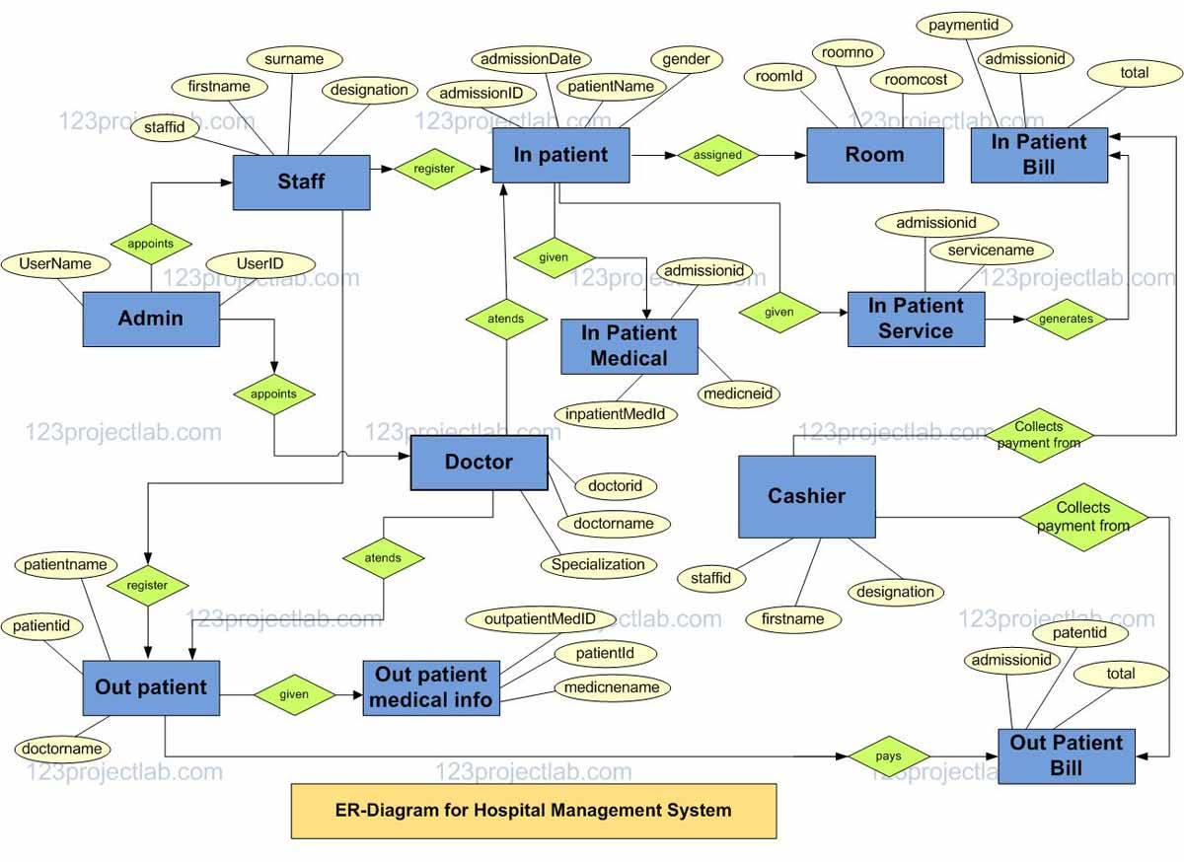

Figure 1. ER-Diagram of Hospital management

**3. LITERATURE REVIEW:**

Literature Survey of Hospital Management Systems:

1. "Design and Implementation of Hospital Management System" by P. Rajasekaran and R. Nanthini, International Journal of Innovative Research in Science, Engineering and Technology, 2016.

- This paper presents the design and implementation of a hospital management system focusing on streamlining hospital operations, patient care, and administrative tasks. It discusses system architecture, database design, and user interface development. The study emphasizes the importance of integrating electronic health records (EHR) and implementing security measures to protect patient data privacy.

2. "Development of Hospital Management Information System (HMIS) for a Multispecialty Hospital" by R. K. Dwivedi, et al., Journal of Healthcare Engineering, 2019.

- This research paper describes the development of a Hospital Management Information System (HMIS) for a multispecialty hospital. It covers system requirements analysis, database design, and software development methodologies. The study highlights the role of HMIS in improving healthcare delivery, resource management, and decision-making processes within the hospital.

3. "Design and Implementation of Hospital Management System" by R. Bharathi and S. V. Kharmate, International Journal of Computer Applications, 2015.

- This paper discusses the design and implementation of a hospital management system with a focus on improving patient care and hospital efficiency. It covers system architecture, database design, and software development methodologies. The study emphasizes the importance of user-friendly interfaces and scalability in adapting to the changing needs of a hospital environment.

4. "Hospital Information Management System (HIMS): An Integration of HIS and ERP" by K. V. Krishnaiah, et al., International Journal of Advanced Computer Science and Applications, 2019.

- This study presents the design and implementation of a Hospital Information Management System (HIMS) that integrates Hospital Information System (HIS) and Enterprise Resource Planning (ERP) functionalities. It discusses system architecture, data integration, and workflow optimization. The research highlights the benefits of HIMS in improving operational efficiency, resource utilization, and decision support in healthcare organizations.

5. "Development and Implementation of Hospital Management System: A Case Study of King Khalid Hospital" by A. M. Abualkibash, et al., Journal of Healthcare Engineering, 2020.

- This paper presents a case study on the development and implementation of a hospital management system at King Khalid Hospital. It covers system requirements analysis, software development, and deployment strategies. The study evaluates the impact of the hospital management system on patient care, staff productivity, and overall hospital performance.

These literature reviews provide insights into various aspects of hospital management systems, including system design, implementation strategies, and the impact on healthcare delivery. They serve as valuable resources for researchers, developers, and healthcare professionals involved in designing and implementing hospital management solutions.

**4.CODE:**

CREATE TABLE Medicine(  
 Medicine_ID INT NOT NULL,  
 M_Name VARCHAR(20) NOT NULL,  
 M_Quantity INT NOT NULL,  
 M_Cost Decimal(10,2),  
 PRIMARY

CREATE TABLE Patient (  
 Patient_ID INT NOT NULL,  
 Patient_FName VARCHAR(20) NOT NULL,  
 Patient_LName VARCHAR(20) NOT NULL,  
 Phone VARCHAR(12) NOT NULL,  
 Blood_Type VARCHAR(5) NOT NULL,  
 Email VARCHAR(50),  
 Gender VARCHAR(10),  
 Condition_ VARCHAR(30),  
 Admission_Date DATE,  
 Discharge_Date DATE,  
 PRIMARY KEY (Patient_ID)  
 );

CREATE TABLE Medical History (  
 Record_ID INT NOT NULL,  
 Patient_ID INT NOT NULL,  
 Allergies VARCHAR(50),  
 Pre_Conditions VARCHAR(50),  
 PRIMARY KEY (Record_ID),  
 FOREIGN KEY (Patient_ID) REFERENCES Patient (Patient_ID)  
 );

CREATE TABLE Appointment (  
 Appt_ID INT NOT NULL,  
 Scheduled_On DATETIME NOT NULL,  
 Date_ DATE,  
 Time_ TIME,  
 Doctor_ID INT NOT NULL,  
 Patient_ID INT NOT NULL,  
 PRIMARY KEY (Appt_ID),  
 FOREIGN KEY (Doctor_ID) REFERENCES Doctor (Doctor_ID),  
 FOREIGN KEY (Patient_ID) REFERENCES Patient (Patient_ID)  
 );

**5. IMPLEMENTATION:**

To implement the provided SQL code for the hospital management database system in your project, you can follow these step-by-step instructions:

**1. Set Up Your Database Environment:**

- Make sure you have MySQL installed and running.

- Connect to your MySQL server using a client like MySQL Workbench or command-line interface.

**2. Execute the SQL Code:**

- Copy the provided SQL code and execute it in your MySQL client. Make sure to create a new database or select an existing one before executing the code.

**3. Verify Table Creation:**

- After executing the SQL code, verify that the tables have been created successfully by checking the database schema.

- Use commands like `SHOW TABLES;` or `DESCRIBE table_name;` to view the tables and their structure.

**4. Start Populating Data:**

- Once the tables are created, you can start populating them with relevant data.

- For example, you can insert patient details into the `Patient` table, medical history information into the `Medical History` table, etc.

**5. Implement Business Logic:**

- Depending on your project requirements, implement additional business logic such as user authentication, data validation, etc.

- Write SQL queries or integrate with a backend programming language to handle user interactions and manipulate data in the database.

**6. TABLES:**

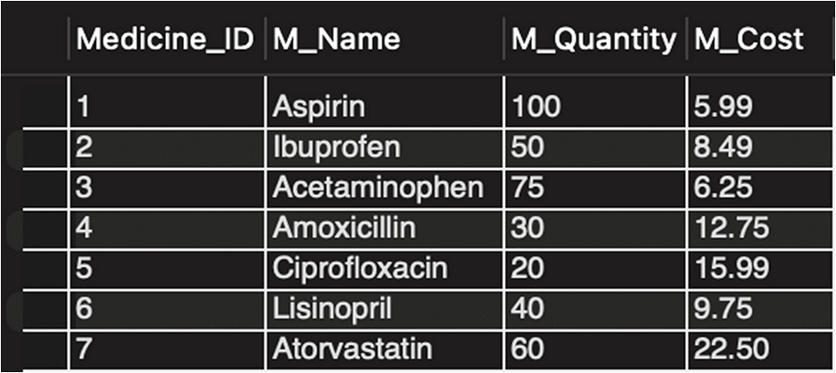

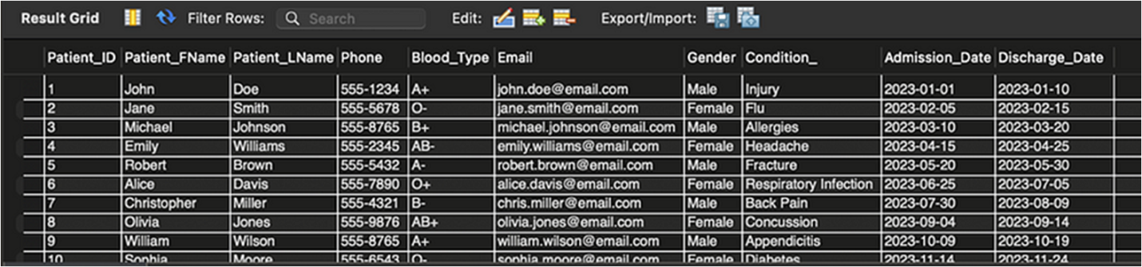

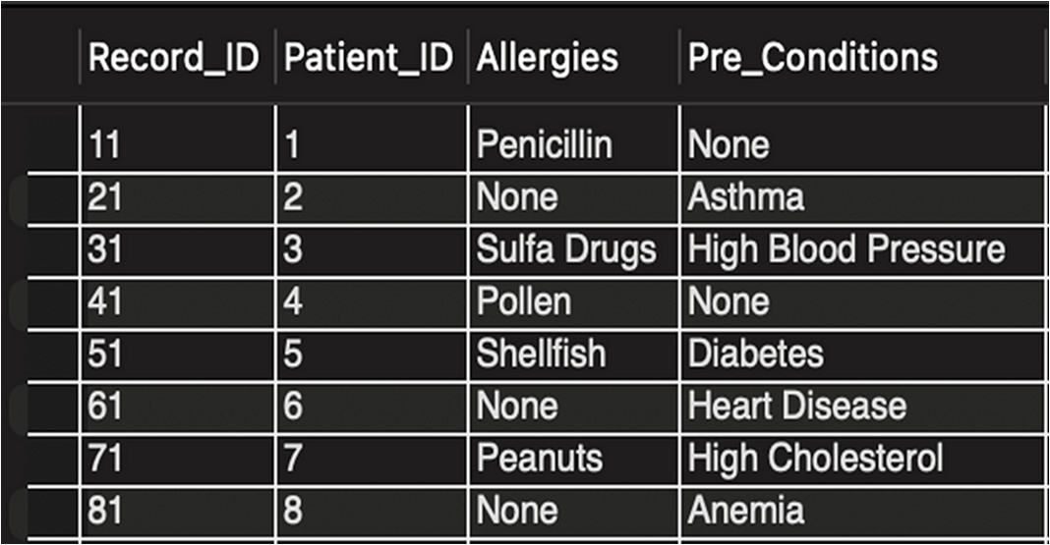

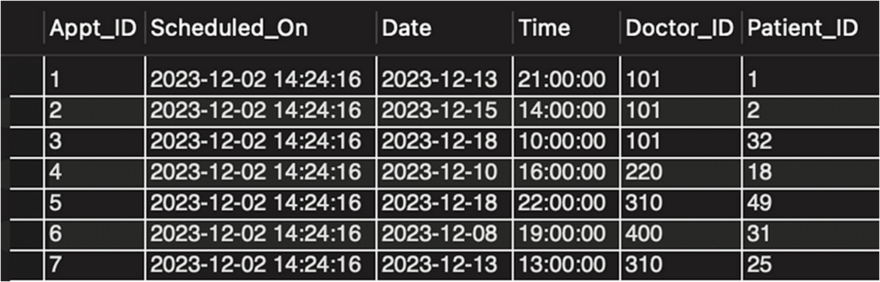

**7. CONCLUSION:**

In conclusion, the implementation of a hospital management database system represents a significant advancement in healthcare administration and patient care. This system effectively streamlines hospital operations, improves resource utilization, and enhances patient outcomes by centralizing and digitizing critical information. By providing healthcare professionals with access to comprehensive patient records, scheduling tools, and medical history data, the system optimizes clinical workflows and facilitates informed decision-making. Additionally, patients benefit from improved accessibility to healthcare services, personalized treatment plans, and enhanced communication with healthcare providers. Overall, the hospital management database system plays a crucial role in improving the efficiency, effectiveness, and quality of healthcare delivery, ultimately leading to better patient satisfaction and outcomes (Refer Figure 1).

**8. FUTURE ENHANCEMENT:**

Looking ahead, several avenues for enhancement exist to further elevate the hospital management database system. Firstly, integrating advanced analytics and reporting features can offer valuable insights into patient demographics, treatment outcomes, and resource utilization, enabling hospitals to optimize their operations and improve patient care. Moreover, incorporating predictive analytics algorithms based on medical data can help identify at-risk patients and proactively manage their healthcare needs, leading to better health outcomes and cost savings.

Additionally, exploring emerging technologies such as telemedicine and Internet of Things (IoT) devices can revolutionize healthcare delivery, offering remote monitoring capabilities, real-time patient data collection, and virtual consultations. By embracing innovation and leveraging evolving technologies, the hospital management database system can continue to evolve and thrive in the dynamic landscape of healthcare.

**- Advanced Analytics:** Implement analytics tools to track patient outcomes, resource utilization, and healthcare trends for informed decision-making.

**- Predictive Analytics:** Develop predictive models to identify patients at risk of adverse health events and intervene proactively to improve outcomes.

**- Telemedicine Integration:** Explore telemedicine platforms to offer remote consultations, virtual follow-ups, and remote patient monitoring.

**- Internet of Things (IoT) Devices:** Incorporate IoT devices such as wearable sensors and smart medical devices for real-time patient data collection and monitoring.

**- Electronic Health Record (EHR) Enhancements:** Enhance EHR functionalities to support interoperability, data sharing, and seamless integration with other healthcare systems.

**- Patient Engagement Tools:** Develop patient portals and mobile apps for patients to access medical records, schedule appointments, and communicate with healthcare providers.

**- Artificial Intelligence (AI) Applications:** Explore AI-driven solutions for medical imaging analysis, diagnosis support, and treatment planning.

**- Blockchain Technology:** Investigate the use of blockchain technology for secure and immutable health data storage and sharing.

**- Compliance with Regulatory Standards:** Ensure compliance with healthcare regulations such as HIPAA (Health Insurance Portability and Accountability Act) to protect patient privacy and security.

**9. REFERENCES:**

Here are references for hospital management:

1. Rajasekaran, P., & Nanthini, R. "Design and Implementation of Hospital Management System." *International Journal of Innovative Research in Science, Engineering and Technology* 3.10 (2016): 24018-24024.

2. Dwivedi, R. K., et al. "Development of Hospital Management Information System (HMIS) for a Multispecialty Hospital." *Journal of Healthcare Engineering* 2019 (2019): 1-11.

3. Bharathi, R., & Kharmate, S. V. "Design and Implementation of Hospital Management System." *International Journal of Computer Applications* 110.7 (2015): 28-32.

4. Krishnaiah, K. V., et al. "Hospital Information Management System (HIMS): An Integration of HIS and ERP." *International Journal of Advanced Computer Science and Applications* 10.4 (2019): 205-211.

5. Abualkibash, A. M., et al. "Development and Implementation of Hospital Management System: A Case Study of King Khalid Hospital." *Journal of Healthcare Engineering* 2020 (2020): 1-10.